**Agile Delivery Services BPA**

**RFQ ID: RFQ993471**

**Pool 2**

**Evidence Item: d**

**Installation Instructions**

1. **Download code/files from GitHub.**

* In your web browser, navigate to this URL: https://github.com/Incatech-Corp/gsa-agile/tree/develop
* Click “Download ZIP” button on bottom right corner of screen:

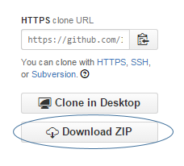

1. **Transfer code package (Step #1) to new machine.**
2. **Unzip code package on new machine.**

* The code/files will need to be placed in the proper location on the new machine. To be accessible from web browsers external to the new machine, the code/files must be place in the web server root directory, or any child folder of the root directory.

1. **Install MySQL on new machine.**

* Download MySQL for your OS here: <http://dev.mysql.com/downloads/>
* Install MySQL on new machine
  + Run installer on new machine (Windows)
  + Run Distribution package on new machine (Linux)

1. **Create database named ‘FoodRecall’ in MySQL on new machine.**

* In MySQL Workbench, click the icon below and follow the instructions.

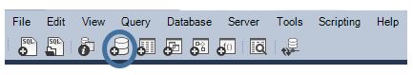

1. **Create tables in MySQL on new machine.**

* From the downloaded files in Step #1, navigate to /prototype installation/ folder, and open the create_table_RecallReportItems.sql file. Copy contents of this file into Query window in MySQL Workbench. Execute query.
* From the downloaded files in Step #1, navigate to /prototype installation/ folder, and open the create_table_statehistorical file. Copy contents of this file into Query window in MySQL Workbench. Execute query.
* From the downloaded files in Step #1, navigate to /prototype installation/ folder, and open the create_table_StatesWeight.sql file. Copy contents of this file into Query window in MySQL Workbench. Execute query.

1. **Create table rows (data) in MySQL on new machine.**

From the downloaded files in Step #1, navigate to /prototype installation/ folder, and open the table_date_RecallReportItems.sql file. Copy contents of this file into Query window in MySQL Workbench. Execute query.

From the downloaded files in Step #1, navigate to /prototype installation/ folder, and open the table_data_statehistorical.sql file. Copy contents of this file into Query window in MySQL Workbench. Execute query.

From the downloaded files in Step #1, navigate to /prototype installation/ folder, and open the table_data_StatesWeight.sql file. Copy contents of this file into Query window in MySQL Workbench. Execute query.

1. **Access prototype via web browser by using your new machine URL, with additional folder names in URL if files were placed in child folder of Root, and accessing index.html.**